

**CONTINUING EDUCATION PROGRAM – CENTER FOR COMPUTING AND INFORMATION TECHNOLOGY**

**FACULTY OF ENGINEERING**

**UNIVERSITY OF INDONESIA**

**MY HOTEL**

2 SC 1

Ian Andika D. S.

Muhamad Hudya Ramdhana

Mutia Ayu Dianita

Faculty : Dudy Fathan Ali, S.Kom

Engineering Center Bulding 1st Floor

Faculty Of Engineering University Of Indonesia

New Campus UI Depok 16424

**Project On**

My Hotel

Developed By

Name : Ian Andika D.S

M Hudya Ramadhana

Mutia Ayu Dianita



**My Hotel**

Batch Code : 2SC1

Start Date : May 10, 2016 End Date : May 17, 2016

Name Of The Coordinator : Dudy Fathan Ali, S.Kom

Name Of Developer : Ian Andika D.S.

Muhamad Hudya Ramadhana

Mutia Ayu Dianita

Date of Submission: May 18, 2016



**CERTIFICATE**

This is to certify that this report **My Hotel** embodies original work done by ***Ian Andika D.S, Muhamad Hudya Ramadhana, Mutia Ayu Dianita***  in partial fulfillment of their course requirement of NIIT .

Coordinator

***Dudy Fathan Ali, S.Kom***

**ACKNOWLEDGEMENT**

We have gained a lot of benefit from feedback, knowledge, and suggestion given to us by Mr. Dudy Fathan Ali, S.Kom. and other faculty members. Therefore we are very grateful for his help in making this project.

**System Analysis**

**System Summary**: The required My Hotel Program should enable user to:

* Create a new data of Room, Class, Customer, Check In, Check Out and access to login the program with username and password.
* Manage and update data of Room, Class, Customer, and Transaction by admin role.
* Do check in and check out and check the data are available or not.
* The total to be paid by the customer has been programmed so that it can calculate automatically.
* Room, Class, Customer, and Transaction data can be search using linear search algorithm and sorted according to the wishes depending on the choice that has been provided in the program using bubble sort algorthm.

**Implementation Details**

The required My Hotel needs to be implemented by using Algorithms and Data Structure such as Array. When a file is loaded on to memory, its contents will be read in Array (.txt), where each index will contain one line of text by Linear Search.

My Hotel also using bubble sort algorithm to sort the employee data and data of food. The data will be sorted by name, price, or age, and choose one filter for example Ascending or Descending.

Program will running if user, choose two of combo box in the form. But if user didn’t choose, message box will appear and give information that user have to choose menu in combo box.

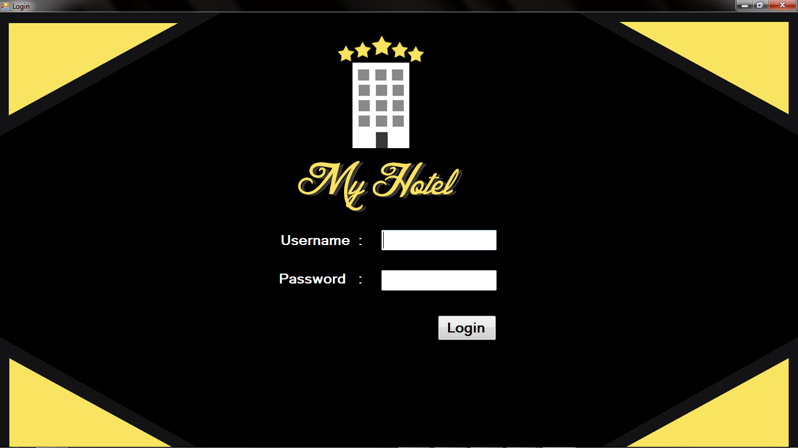

*Login Panel*

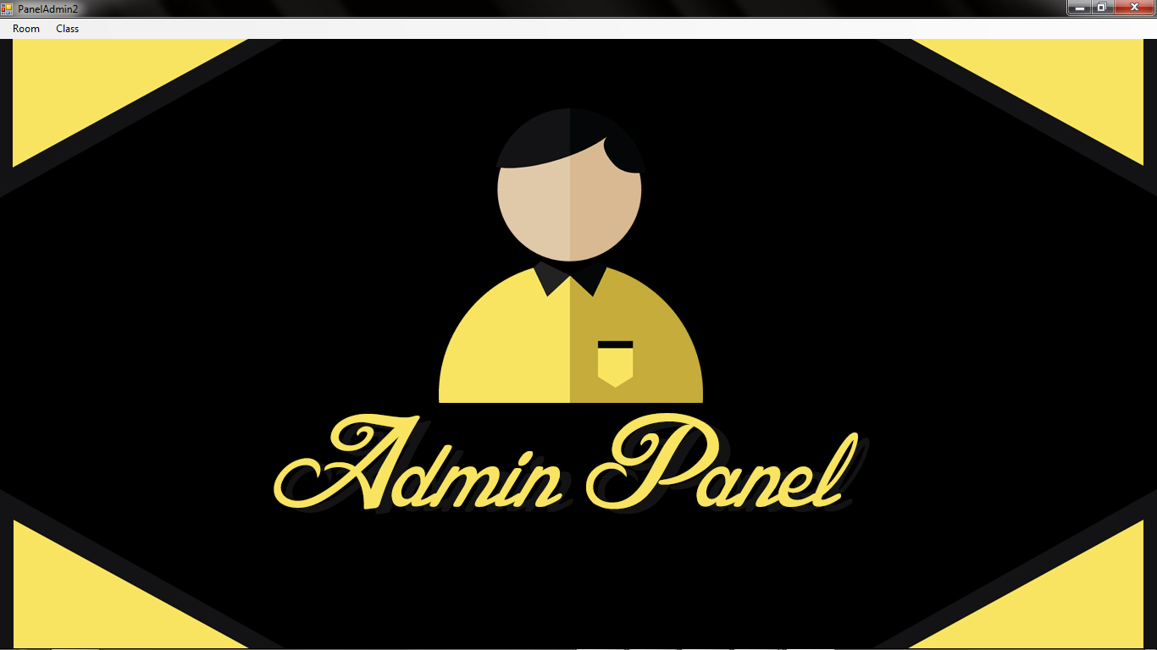

*Admin Panel*

**Interface Design for The Hotel Application**

**PROBLEMS ENCOUNTERED**

Some of the problems experienced in the writing of the inventor of this project are as follows :

* We have just learned to make Algorithm and and we still lay in managing Data Structure in programming code.
* Difficult in making Algorithm is the algorithm should be suitable with the program which programmer need to choose and execute exactly algorithm.
* We do not have any experience in doing projects like that given at this time.

**CONFIGURATION**

**Hardware:** IntelR CoreTM i3-2450M CPU @ 2,20GHz 2,10 GHz, 4.00GB RAM, 500 GB HDD,ASUS X450 802.11b/g/n,6 cell Li-ion battery

**Operating System:** Windows 7

**Software:** Microsoft Visual Studio 2010, Microsoft Office Word 2013.

|  |  |  |
| --- | --- | --- |
| **PROJECT FILE DETAILS** | | |
| **S.No** | **File Name** | **Remarks** |
| 1 | Hotel.sln | MS. Visual Studio 2010 |
|
|

**Individual Project Schedule**

|  |  |  |  |  |  |
| --- | --- | --- | --- | --- | --- |
| S. No. | Activity Description | Planned Date of Completion | Actual Date | Responsibility | Remarks |
| 1. | Writing code for Implementing a ArrayList | 10th May | 11st May | Hudya |  |
| 2. | Writing Code for Implementing a Bubble Sort Algorithm | 12nd May | 13rd May | Mutia |  |
| 3. | Writing code for Implementing a Linear Search | 13rd May | 13rd May | Hudya |  |
| 3. | Writing code for validation | 14th May | 16th May | Ian |  |
| 4. | Search Bug and solve | 16th May | 17th May | Ian |  |
| 5. | Design Program | 17th May | 17th May | Mutia |  |

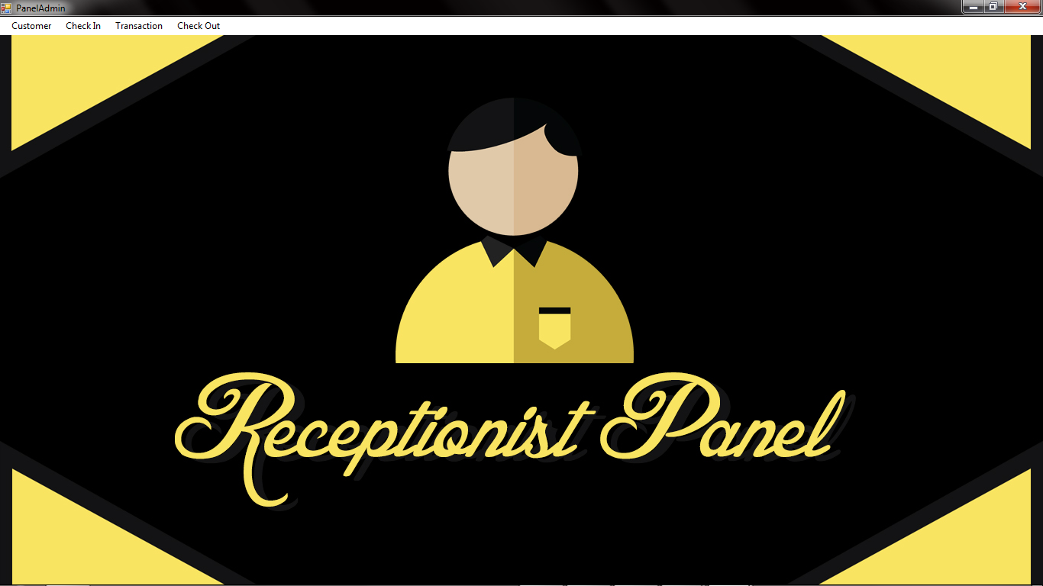

*Receptionist Panel*

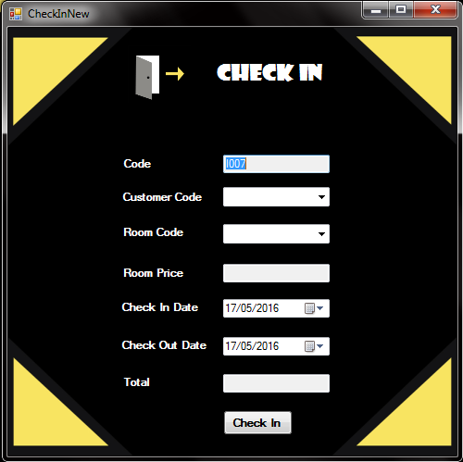

*New Check In*

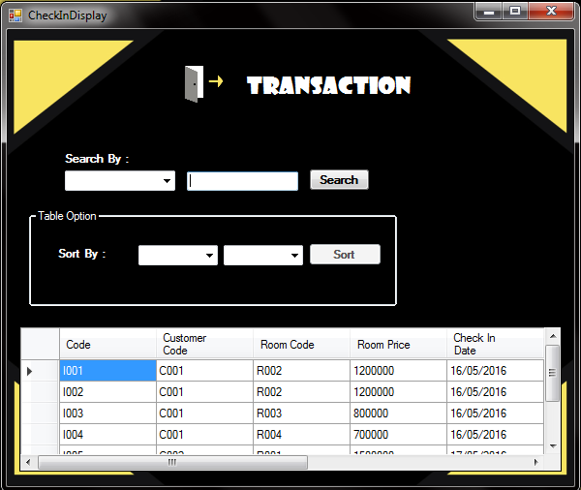

*Transaction Display*

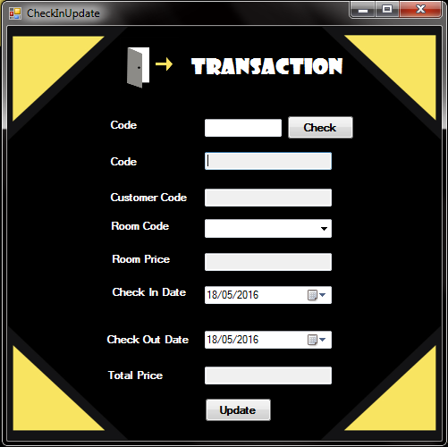

*Transaction Update*

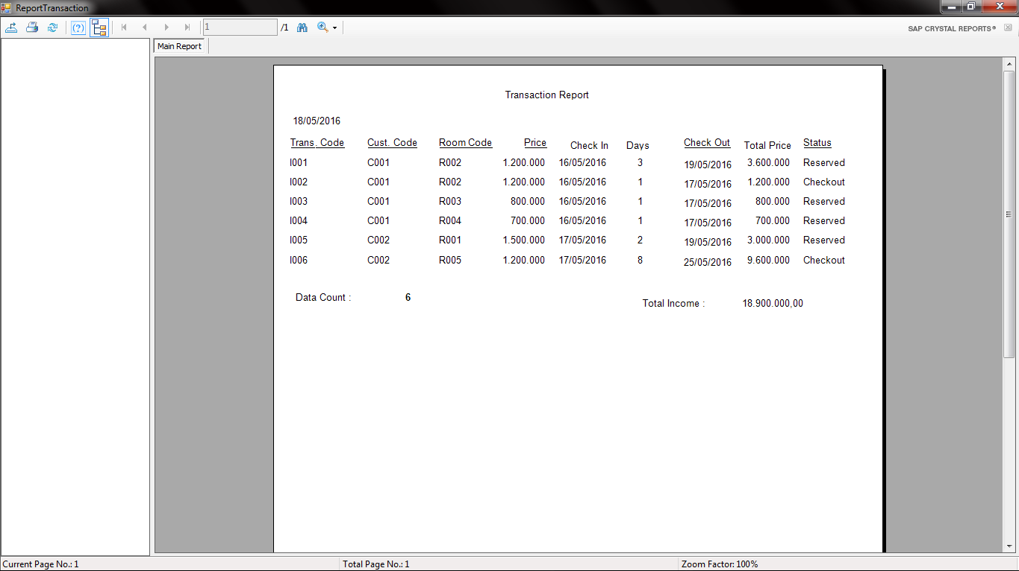

*Transaction Report*

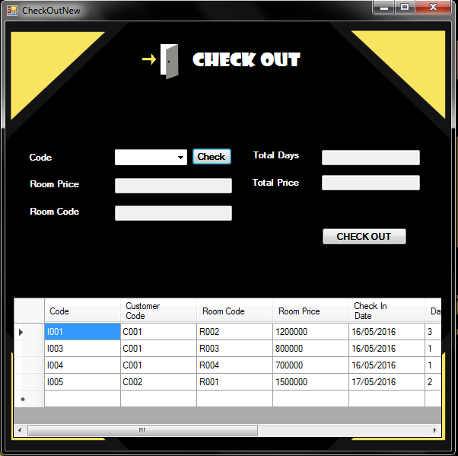

*Check Out Panel*